Abide is an unscheduled prayer experience for college students, high school seniors, and adults who work with college students. Abide is designed to be a time of retreat. There is an opening session Friday night and a closing session Saturday afternoon. Everything in between is up to you. There will be various stations prepared by Student Lead Team members to help you pray and connect with God. Sit by the water. Spend some time next to the bonfire. Sleep. Listen to the quiet. Pray for your campus and the world. Enjoy the cool weather. Take a walk by yourself. Have coffee with a friend.
www.texasbaptists.org/abide

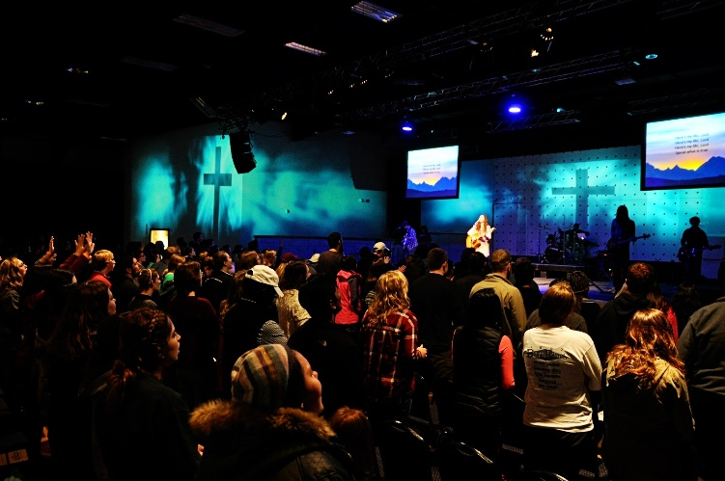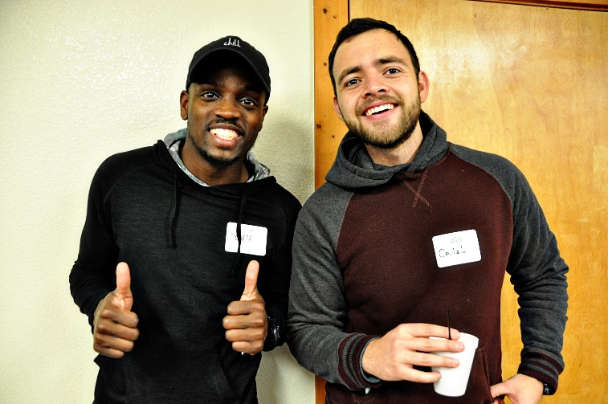
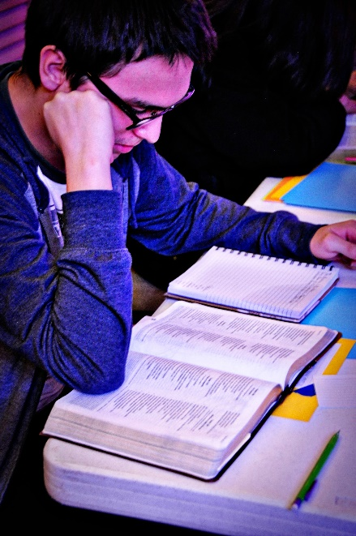

Abide is an unscheduled prayer experience for college students, high school seniors, and adults who work with college students. Abide is designed to be a time of retreat. There is an opening session Friday night and a closing session Saturday afternoon. Everything in between is up to you. There will be various stations prepared by Student Lead Team members to help you pray and connect with God. Sit by the water. Spend some time next to the bonfire. Sleep. Listen to the quiet. Pray for your campus and the world. Enjoy the cool weather. Take a walk by yourself. Have coffee with a friend.
www.texasbaptists.org/abide

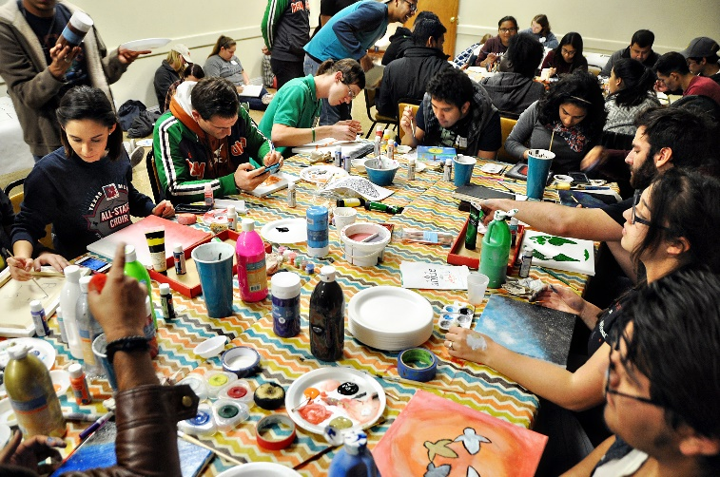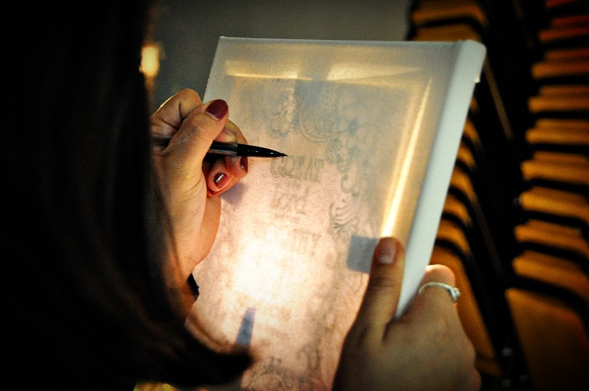

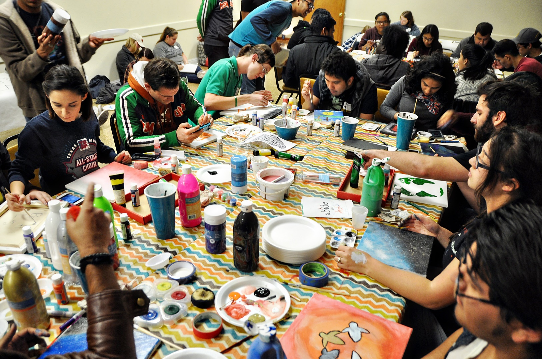
Abide is an unscheduled prayer experience for college students, high school seniors, and adults who work with college students. Abide is designed to be a time of retreat. There is an opening session Friday night and a closing session Saturday afternoon. Everything in between is up to you. There will be various stations prepared by Student Lead Team members to help you pray and connect with God. Sit by the water. Spend some time next to the bonfire. Sleep. Listen to the quiet. Pray for your campus and the world. Enjoy the cool weather. Take a walk by yourself. Have coffee with a friend.

www.texasbaptists.org/abide

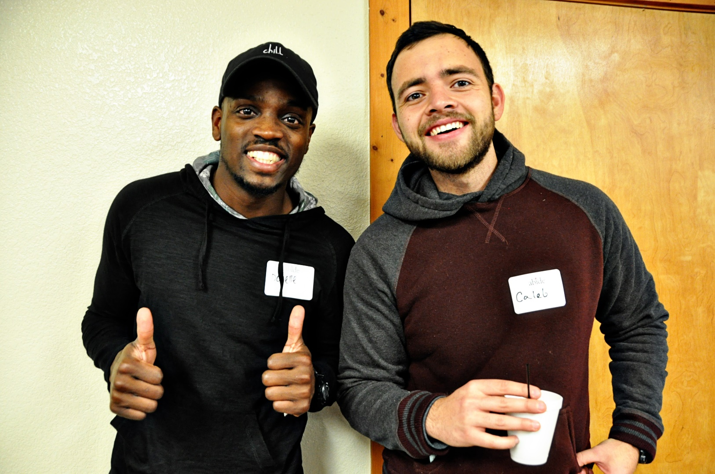
Abide is an unscheduled prayer experience for college students, high school seniors, and adults who work with college students. Abide is designed to be a time of retreat. There is an opening session Friday night and a closing session Saturday afternoon. Everything in between is up to you. There will be various stations prepared by Student Lead Team members to help you pray and connect with God. Sit by the water. Spend some time next to the bonfire. Sleep. Listen to the quiet. Pray for your campus and the world. Enjoy the cool weather. Take a walk by yourself. Have coffee with a friend.

www.texasbaptists.org/abide

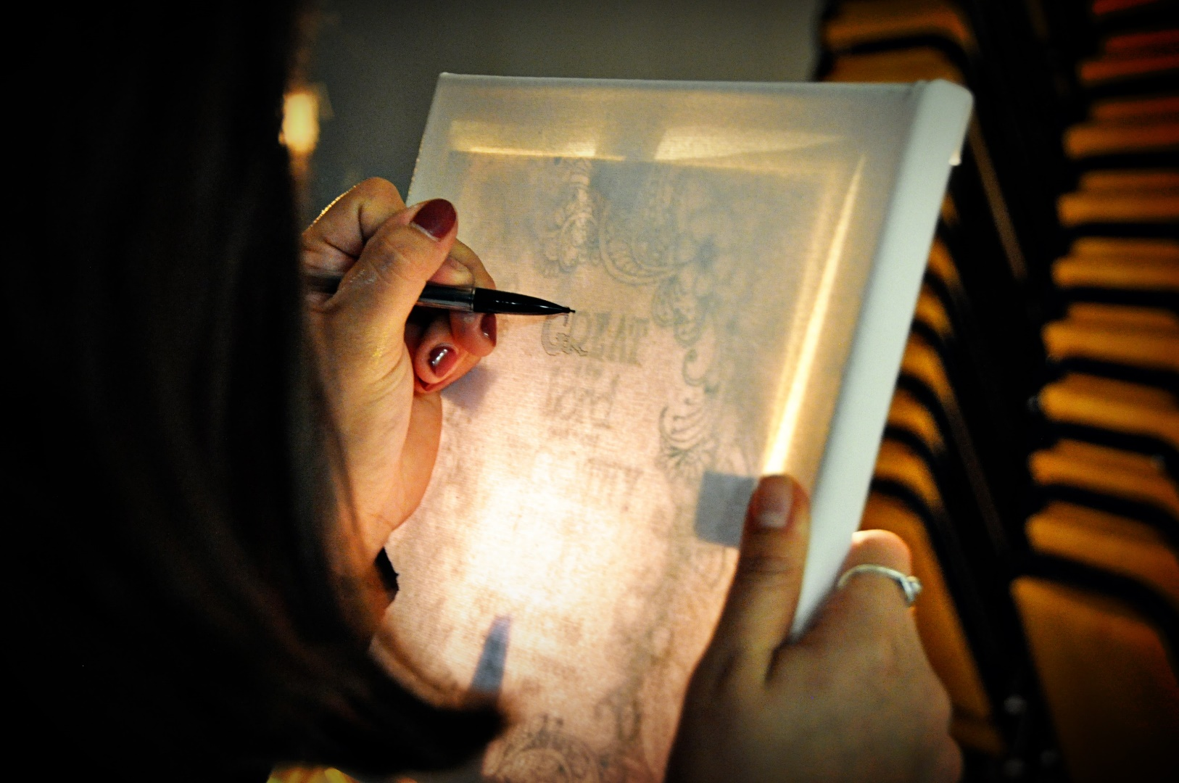
Abide is an unscheduled prayer experience for college students, high school seniors, and adults who work with college students. Abide is designed to be a time of retreat. There is an opening session Friday night and a closing session Saturday afternoon. Everything in between is up to you. There will be various stations prepared by Student Lead Team members to help you pray and connect with God. Sit by the water. Spend some time next to the bonfire. Sleep. Listen to the quiet. Pray for your campus and the world. Enjoy the cool weather. Take a walk by yourself. Have coffee with a friend.

www.texasbaptists.org/abide

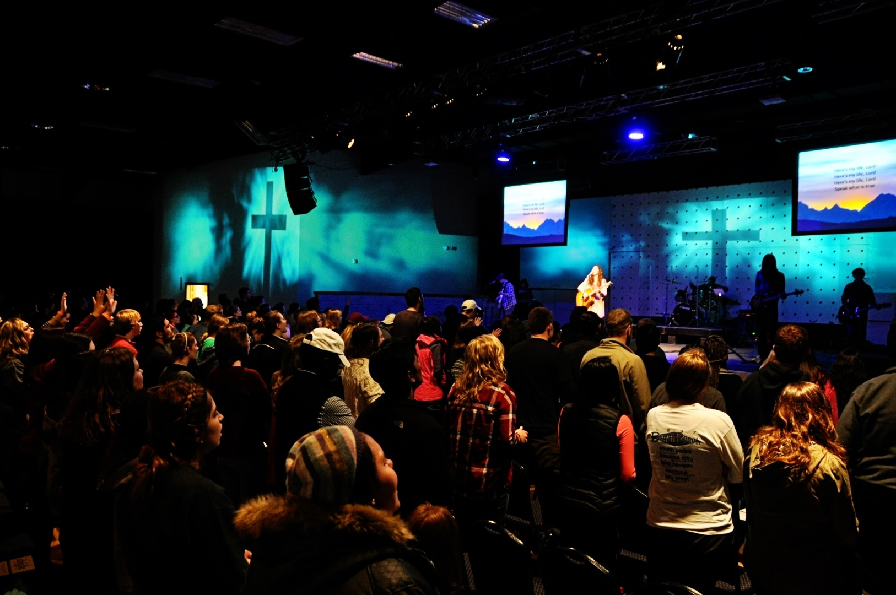
Abide is an unscheduled prayer experience for college students, high school seniors, and adults who work with college students. Abide is designed to be a time of retreat. There is an opening session Friday night and a closing session Saturday afternoon. Everything in between is up to you. There will be various stations prepared by Student Lead Team members to help you pray and connect with God. Sit by the water. Spend some time next to the bonfire. Sleep. Listen to the quiet. Pray for your campus and the world. Enjoy the cool weather. Take a walk by yourself. Have coffee with a friend.

www.texasbaptists.org/abide

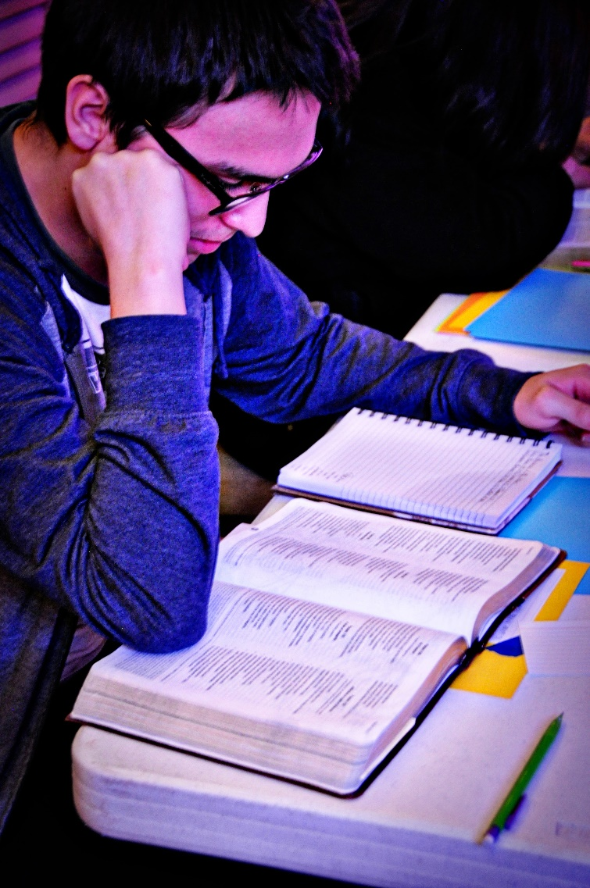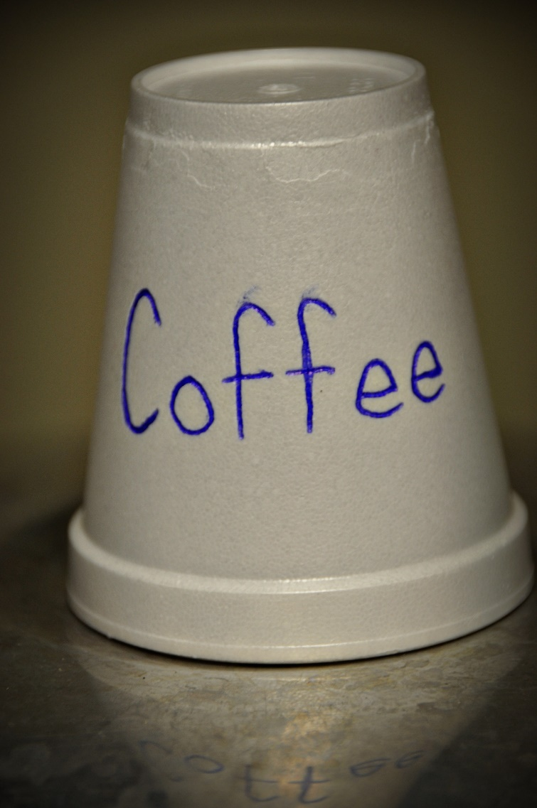
Abide is an unscheduled prayer experience for college students, high school seniors, and adults who work with college students. Abide is designed to be a time of retreat. There is an opening session Friday night and a closing session Saturday afternoon. Everything in between is up to you. There will be various stations prepared by Student Lead Team members to help you pray and connect with God. Sit by the water. Spend some time next to the bonfire. Sleep. Listen to the quiet. Pray for your campus and the world. Enjoy the cool weather. Take a walk by yourself. Have coffee with a friend.

www.texasbaptists.org/abide

